CALL FOR PARTICIPANTS
ELIST - European Learning Innovation for Sustainable Training
Transnational Training III on Multiplication
20th – 24th June 2016
Costa da Caparica, PORTUGAL
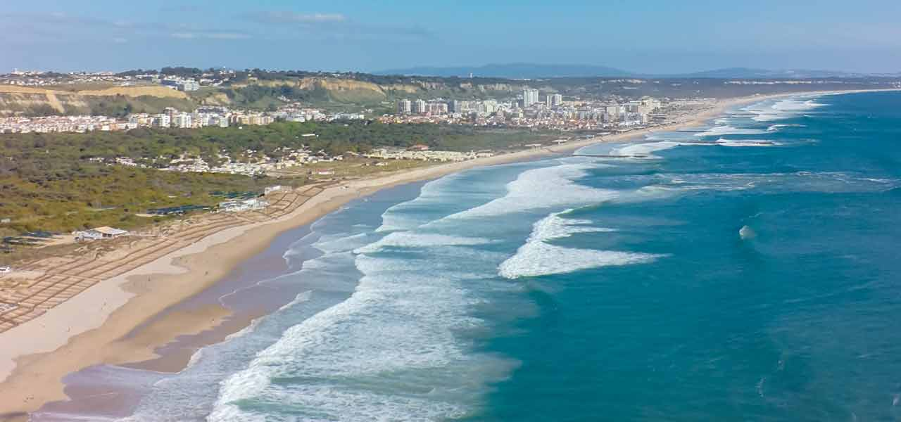
A training event under the umbrella of project ELIST, co-funded by the programme ERASMUS+ of the European Union
Project “ELIST European Learning Innovation for Sustainable Training”
Project reference -2014-1-IT02-KA204-003644
This project has been funded with support from the European Commission.
This publication [communication] reflects the views only of the author, and the Commission cannot be held responsible for any use which may be made of the Information contained therein.

DESCRIPTION
Transnational Training III within “Elist - European Learning Innovation for Sustainable Training” context is a 5 days Training Course for Multipliers (TCM), in which 35 participants, from 7 countries, will have the opportunity to improve their competences (attitudes/behaviors, knowledge, and skills) as Multipliers. These participants will be recognized at EU level as the ELIST4M team.
Multipliers? What is the role of ELIST Multiplier and the role of the ELIST4M team?
The ELIST4M team member will be capable to:
- to spread information about the project ELIST and its results;
- to motivate potential users of the project ELIST results;
- to increase the number of initiatives generated and inspired from the project ELIST and its results;
- to increase the quality of projects initiatives generated and inspired from the project ELIST and its results;
- to take stock from the events organized for the multiplication of the project ELIST and its results and deliver feedbacks to the ELIST Observatory Committee (EOC).
In that way, the ELIST4M team member role is to globally contribute the main goal of the project Elist, that is to have a positive impact on local development in a sustainable way, considering the environment, the economy and the social context of their communities.
This TCM also aim at facilitating participants who want to enhance their competences, and also who want pass and share their own experiences as multipliers to support others with less experience. Participants should gain practical experience through the TCM, learning new competences and teamwork methodologies, plan and run activities. Summarizing, the TCM aim at making it easier for multipliers to create exchanges, influence and participate in a variety of parts of the project ELIST.
Formal, non-formal and informal education and training practitioners, members of Civil Society Organisations (NGO, etc.), and active citizens globally, are welcome to participate as they can learn from each other and create mutually beneficial and self-sustaining relationships, and they can generate ideas for multiplication events and initiatives.
The methodology implemented in the TCM will be essentially practical (in-door, outdoor), namely: group work, trigger and reflection groups for assessment. Commonly group dynamics methodologies will be implemented such as (to name but a few): Samoan Circle, Open Source Methodology, World Café, serious game, forum theatre and Human Library.
OBJECTIVES OF THE TCM
- To describe what is it to be a multiplier and how to act in their community.
- To train participants in event management.
- To train participants in non-formal and informal training methodologies.
- To train participants in identifying, selecting and practicing multiplier events.
- To assign participants in organizing within their groups the ELIST official Multiplier Event of Aldeia Lusófona.

CRITERIA OF ELIGIBILITY
- This course is eligible strictly for citizens of the following countries: Austria, Turkey, Bulgaria, Italy, Greece, Spain, and Portugal.
- To be accepted, and to be eligible for the EU grant, the participant must be present at the first and last sessions of the TCM (see annexed agenda).
- Participants must attend all the TCM sessions from the first to the last, with the reserve of exceptional conditions related to health and care.
- Participants must attend the TCM with a pro-active attitude and follow strictly the recommendation of the hosting/coordinating organisation.
- Participants will have to complete all their assignments to be eligible for refunding; assignments are exercises and tasks requested to the participants for the TCM purpose strictly.
- Participants must keep all invoices and related proofs of expenses such as tickets (bus, train, plane, etc.), keep their boarding passes; this documentation will have to be delivered in original to their respective sending organisation.
WHEN AND WHERE
The training course will take place in the town of Costa da Caparica (Greater Lisbon Area), on the south side of the Tagus river, and at walking distance of the Atlantic Ocean.
Arrival day of participants: Monday the 20th, June 2016, before the start of the first session
Departure day of participants: Friday the 19th, June 2016, after the end of the last session
Participants will be hosted in the Hotel Praia e Sol, Costa da Caparica (2 stars) and will be sharing a room with another participant (e.g. 2 pax/room).
http://www.praiadosolhotel.com/
NB. To be accepted in the TCM, and to be eligible for the EU grant, the participant must be present at the first and last sessions of the TCM.
COSTS
This project has been funded with the support of the Erasmus+ Programme considering the following agreed grant amounts:
- Travel € 275,00
- Subsistence (accommodation and food) € 275,00
- Total € 550,00

Summary for traveling, accommodation and subsistence - The details of refunding will be specified by individual contracts signed between the participant and their respective sending organisation.
- Traveling
Participants must keep all invoices and related proofs of expenses such as tickets (bus, train, plane, etc.), keep their boarding passes; this documentation will have to be delivered in original to their respective sending organisation.
Spain: Fundación Docete Omnes
Bulgaria: Association Generations
Turkey: Trakya University
Greece: ACADEMY OF ENTREPRENEURSHIP - ASTIKI ETAIRIA
Italy: GAL Fior d’Olivi
Austria: E.N.T.E.R. GMBH
Portugal: ALDEIA LUSOFONA - Associação para o Desenvolvimento Intercomunitário
The details of refunding will be specified by individual contracts signed between the participant and their respective sending organisation.
- Accommodation and food - € 40,00 per day and per participant
Hotel Praia e Sol, Costa da Caparica (2 stars), accommodation in double rooms, including the VAT, the tourist tax, one breakfast per participant, 1 lunch per participant, and 1 diner per participant.
TRAINING SET-UP AND BACKGROUND
The TCM is delivered as step for the exploitation of results of the project ELIST that a consortium of seven partners is implementing with the Erasmus + Project (KA 2 for adult education) “European Learning Innovation for Sustainable Training – ELIST”, coordinated by the Italian Local Action Group “GAL Fior d’Olivi”).
The training days are organized with the following sessions:
- Morning session (anticipated 9h30 to 12h30)
Participants will be dynamically introduced to concepts and methodologies. It means that participants will actively cooperate with practical and experiential methods, namely with good practices sharing.
No laptops, no PC, no MS PowerPoint presentation here!
- Afternoon session (anticipated 14h30 to 17h00)
Participants will be assigned to develop group activities.
- Late session (anticipated 18h30 to 19h00)
Participants will gather for a short group meeting to contribute to their reflection group aiming at adjusting and aligning the TCM for the following days.

The subjects globally addressed by the TCM are:
- Visibility: how to make a project or initiative visible or enhance its visibility.
- Engagement: how to encourage individuals, organisations and communities in implementing ELIST project results.
- Team work: group dynamics, leadership and partnering.
- Competences: communication, organisation, coordination, motivation, training methodologies and event management.
APPLICATION PROCEDURE
Kindly find attached the application form, which is to be completed before 30th, April 2016.
Should you require any specific information, kindly contact your respective country’s referent at:
Austria: E.N.T.E.R. GMBH petra.kampf@enter-network.eu
Bulgaria: Association Generations generationsbg@abv.bg
Greece: ACADEMY OF ENTREPRENEURSHIP ASTIKIETAIRIA research@akep.eu
Italy: GAL Fior d’olivi elist.erasmusplus.training@gmail.com
Portugal: ALDEIA LUSOFONA bruno.europ@gmail.com
Spain: Fundación Docete Omnes europa@doceteomnes.com
Turkey: TRAKYA UNIVERSITY muratyorulmaz2288@hotmail.com
More detailed information will be provided timely to the selected participants by their respective referents.

